Number To Word Converter
This is a console application in Python, that prints the word equivalent in English for a given integer.

Sample screenshots:

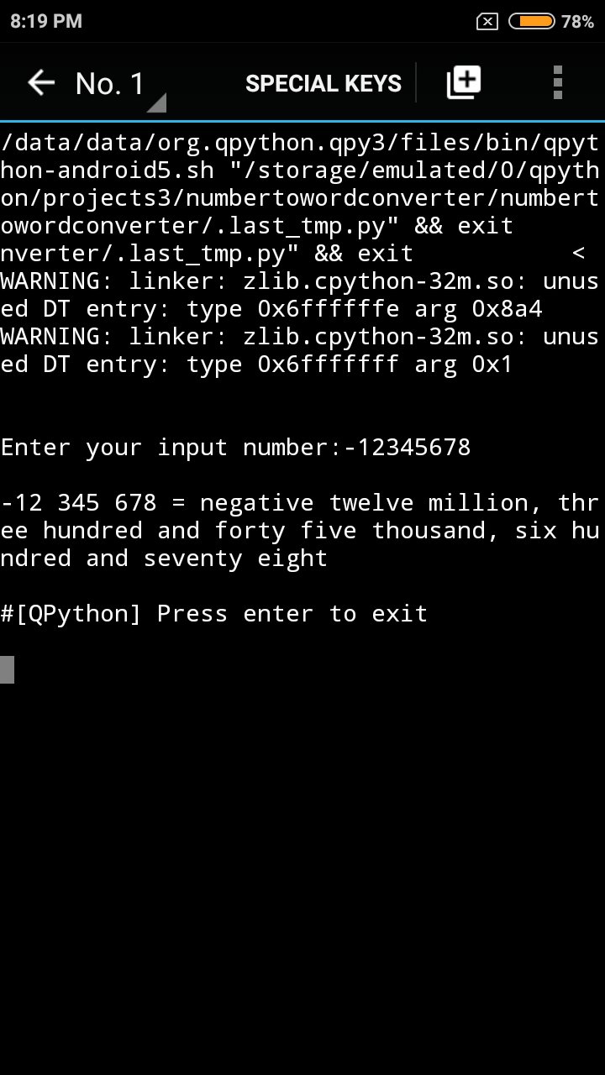

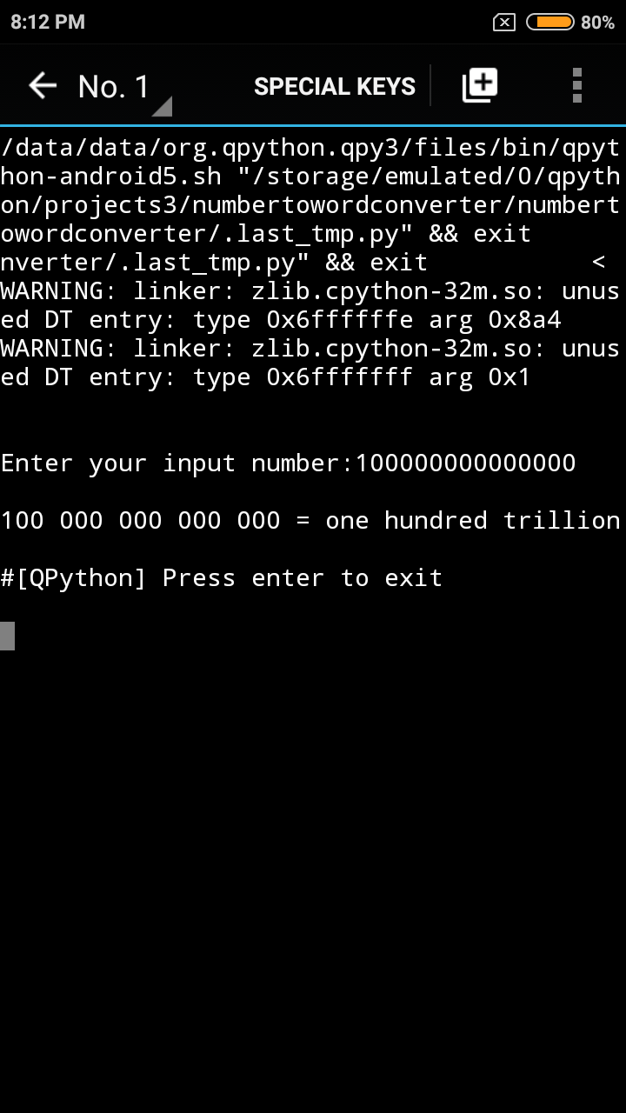

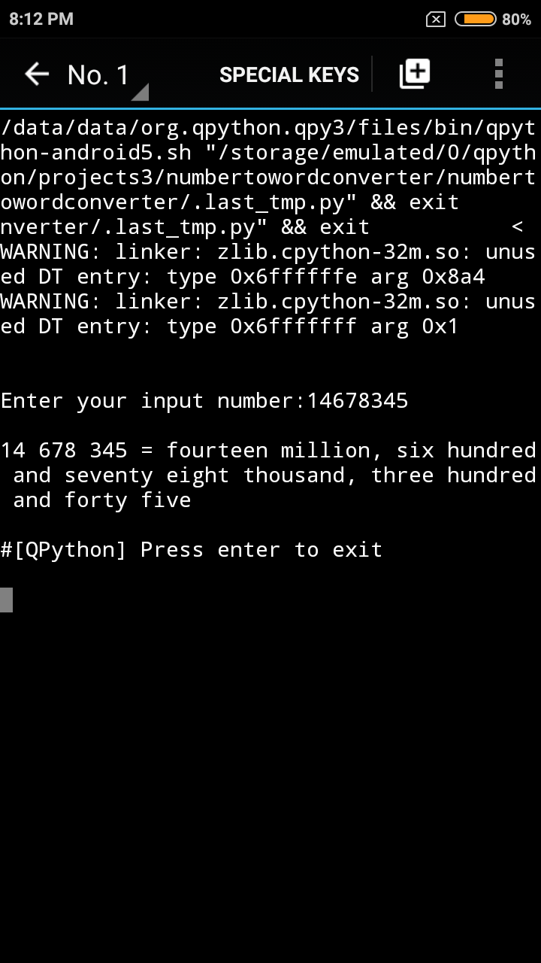

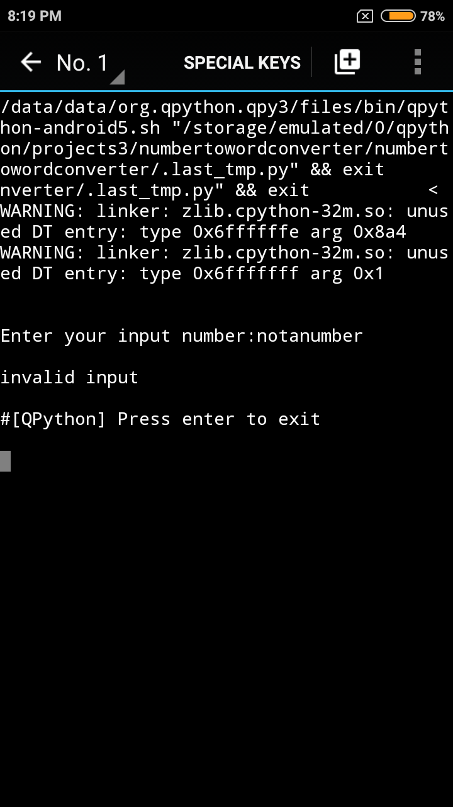

Distribution File
numbertowordconverter-0.0.1-py3-none-any.zip - Unzip this to your Python projects folder and run numbertowordconverter-0.0.1-py3-none-any/numbertowordconverter/main.py
numbertowordconverter-0.0.1-py3-none-any.whl is also available. I face some issue while trying to install using pip install --no-index --find-links <path to the.whl file on local disk>; could not figure out a solution. Also, kindly note that the entire development and documentation was done on my Android phone with qpython3 app and that no testing could be done on another device as no other system was available.

Design

Class: Number
Location: /numbertowordconverter.py
The Number class has all the properties and methods required to achieve number to word conversion.
Note: Variable and method names might be slightly different in code. The important methods are listed here.

Properties
number - holds the number value
sign - holds the sign

Methods

getWordRep(self)
Returns the word representation of the number that the object holds

getFormattedNumber(self)
Returns the number in a readable format

getSignInWord(self)
Returns sign in word

getNumber(self), getSign(self)
Returns number and the sign

Dictionary file
Location: /numberdictionaries.py
Holds the dictionaries used in the project

Additional files
/main.py
Contains the call to convertToWord(inputStr) function, which creates a Number class object and invokes the method that gives the word representation of the input.

Test Class

MyTest class
Contains necessary test cases written using Python's 'unittest' class.
Location: /tests/test_conversion.py

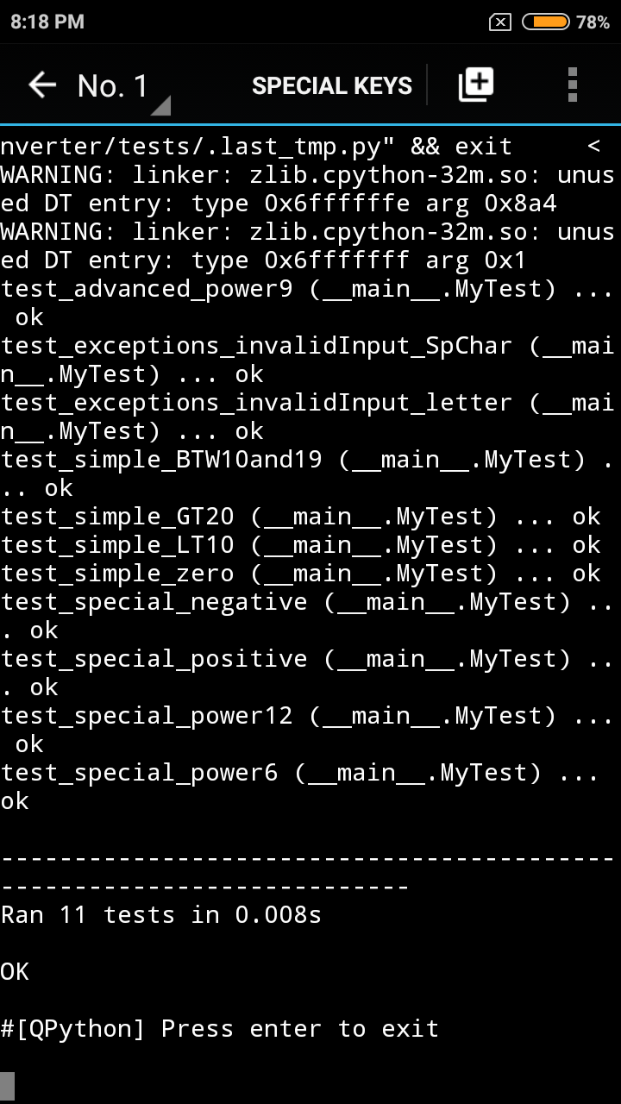
Screenshot

